VEHICLE CRIME INVESTIGATORS ASSOCIATION

CONFERENCE
October 5-6, 2022

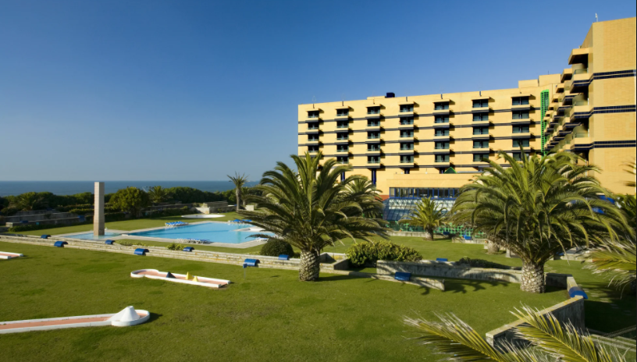

PLEASE FILL IN WITH COMPUTER - FOR EACH PARTICIPANT USE 1 FORM
HOTEL SOLVERDE
Spa & Welness Center
Avenida da Liberdade, 2112 –
410-154 S.F.
Marinha V.N. Gaia PORTUGAL

REGISTRATIONS: LATEST ON 15 September 2022 and upon availability

- Your personal information

Name : ……

Address : ……

City : …… Country: ……

E-mail address : …… Phone number: ……

Profession : …… Law enforcement : yes/ no

Companion (non attendee of the seminar)

Name : ……

- PARTICIPATION

Your name and e-mail address will be mentioned on the participants list which will be send by e-mail after the Conference to all participants.

- Your hotel and conference fees

a. HOTEL

Hotel rooms upon availability at
€ 92,40 Standard Single
€ 105,60 Standard Double room.

All you have to do is log on to website:
https://www.gruposolverde.pt/hotel-solverde-spa-wellness-center/
Choose the date of the event
How many people
Use the promo code: VCI Seminar

b. CONFERENCE-FEE

 |  | Members/  Police | NON Members | Companions
Total conference package | Conference/coffee/  2 x lunch and 2 x dinner | 325 | 425 | 200
Wednesday conference  only | Conference/coffee/lunch  Dinner | 120  60 | 160  70 | 60
Thursday  Conference  only | Conference/coffee/lunch  Gala Dinner | 120  80 | 160  90 | 80
Total
COMPANIONS (= non attending conference)

TOTAL PRICE: €....... Attendees + companions

If two registered attendees stay in a double room (non-companion), please provide the name of the attendee with whom you are sharing the room with (also enclose second registration-form= on his/her name)
Name second attendee in the double room: …………………

- Your payment

Your registration is only official with prove of payment attached or with valid creditcard number

Payment by credit card or by international bank transfer.
Please select your payment method and provide the necessary information.

If you pay by credit card:

Please check one: VISA MasterCard Eurocard

Account Number: ( _ _ _ _ ) ( _ _ _ _ ) ( _ _ _ _ ) ( _ _ _ _ )

Expiration Date:……..…/…………

Name of the cardholder:

…………………………………………………………………………………….

If you pay by international bank transfer:
Name of the account: VCI Izvw, Bergstraat 50, B9820 MERELBEKE, Belgium
IBAN: BE43 310-1909360-01
BIC: BBRUBEBB

CANCELLATION POLICY:

Until 15 September, 2022 without costs.
Note: In case of a “no-show” or any other cancellations after September 15,2022, there is no refund !

- Send us your reservation form

Return your registration form to:

Franky Dedeurwaerder
E-mail : treasurer@vci.team

And CC to : president@vci.team

